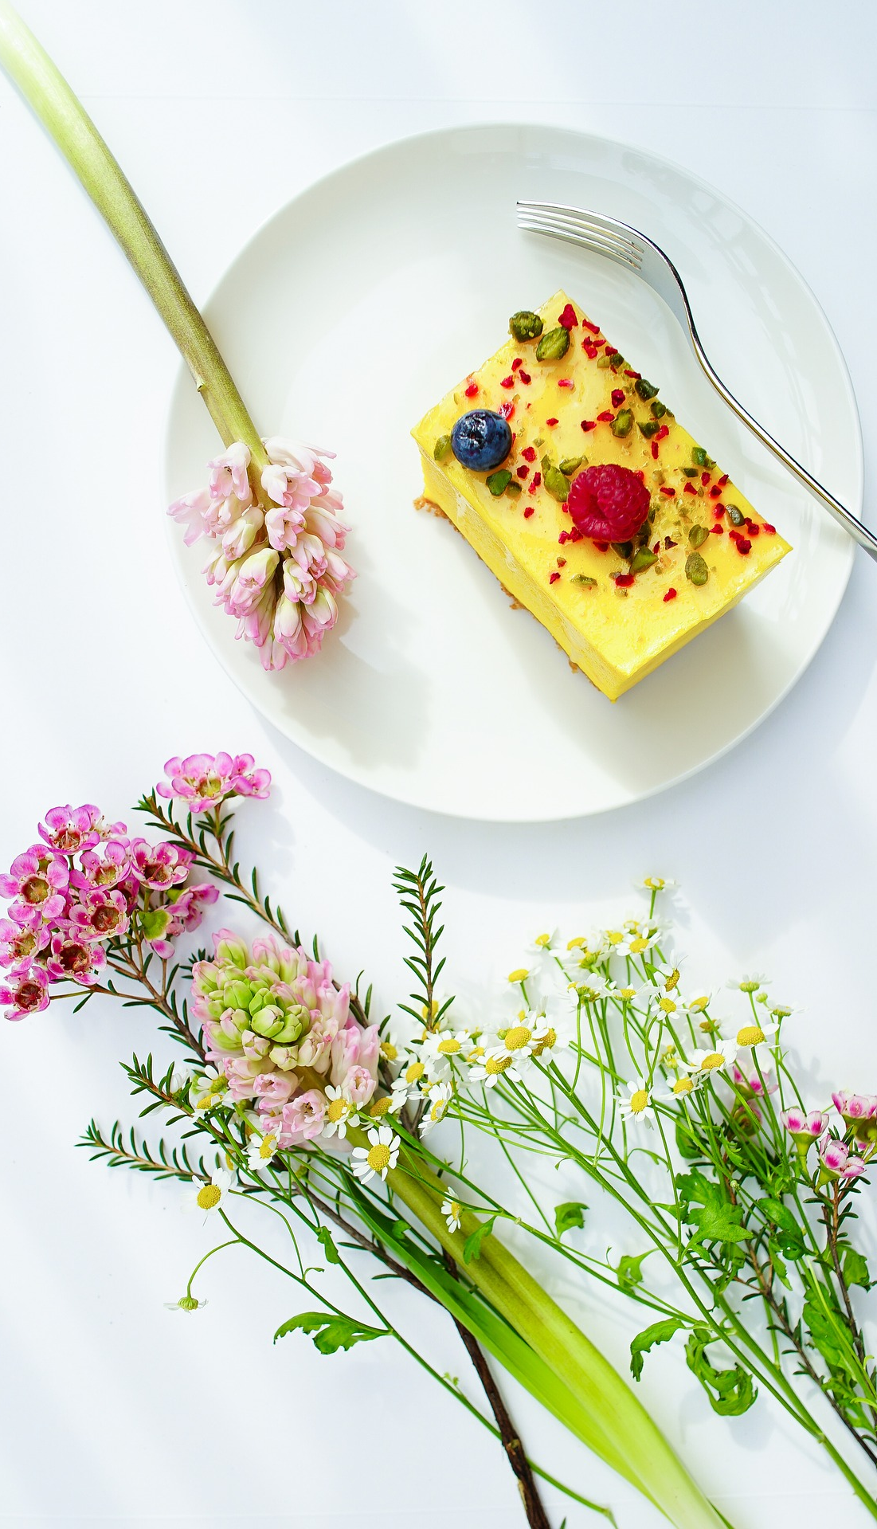
 | ENERGY BITES  $4.00 A BAG | PEANUT BUTTER & CHOCOLATE CHIP, COCONUT, ADDICT, BLUEBERRY MUFFIN, OATMEAL RAISIN, DOUBLE CHOCOLATE CHIP, GRANOLA, CHERRY CHOCOLATE CHIP, CHIA CRANBERRY  THE BASE IS PEANUT BUTTER, AGAVE, VANILLA, OATS
 | INDIVIDUAL BARS  $4.00 PER BAR | PEANUT BUTTER BAR  SCOTCHAROOS
 | INDIVIDUAL BROWNIES  $3.00 PER BROWNIE | PICK YOUR FLAVOR: PLAIN, DUSTED POWDER SUGAR, FROSTINGS: VANILLA, CHOCOALTE, CREAM CHEESE, PEANUT BUTTER, COOKIES & CREAM, COOKIE DOUGH FILLING
 | COOKIES  $2.50 PER COOKIE | PICK YOUR FLAVOR: CHOCOLATE CHIP, PEANUT BUTTER, DOUBLE CHOCOLATE, PEANUT BUTTER AND CHOCOLATE CHIP, OATMEAL RAISIN, MOLASSES, SUGAR COOKIE, SHORTBREAD COOKIE
 | CANDY  $2.50 PER CANDY | ALMOND JOY  PEANUT BUTTER CUP
 | CAKE FLAVORS  PRICE VARIES ON SIZE | CHOCOLATE OR VANILLA WITH A CHOCOLATE GANACHE AND TOFFE  CHOCOLATE OR VANILLA WITH MINT CHOCOLATE CHIP FROSTING  DUO CAKE( VANILLA CAKE WITH BROWNIE LAYER) WITH VANILLA AND FUDGE FROSTING

INDIVIDUAL ITEMS

&

MORE CAKE FLAVORS

